SOCIAL SCIENCE : CHAPTER 9
FAMILY AND COMMUNITY

What is a Family?
- A family is a group of people who are related to each other.
- They live together and care for one another.
- A family provides love, support, and protection.

Family Tree
- A family tree shows how family members are related to each other.
- It starts with grandparents at the top, then parents, and then children.
- It helps us know about our ancestors and relatives
Onam
- Onam is a major festival of Kerala.
- Celebrated to welcome King Mahabali, who is believed to visit Kerala during Onam.
- People make floral designs (Pookalam), wear new clothes, and prepare special food called Onasadya.
- It shows the joy and togetherness of the community and family.

Role of Members in a Family
Every family member has a role and responsibility:
  - Parents: Earn, guide, and take care of children.
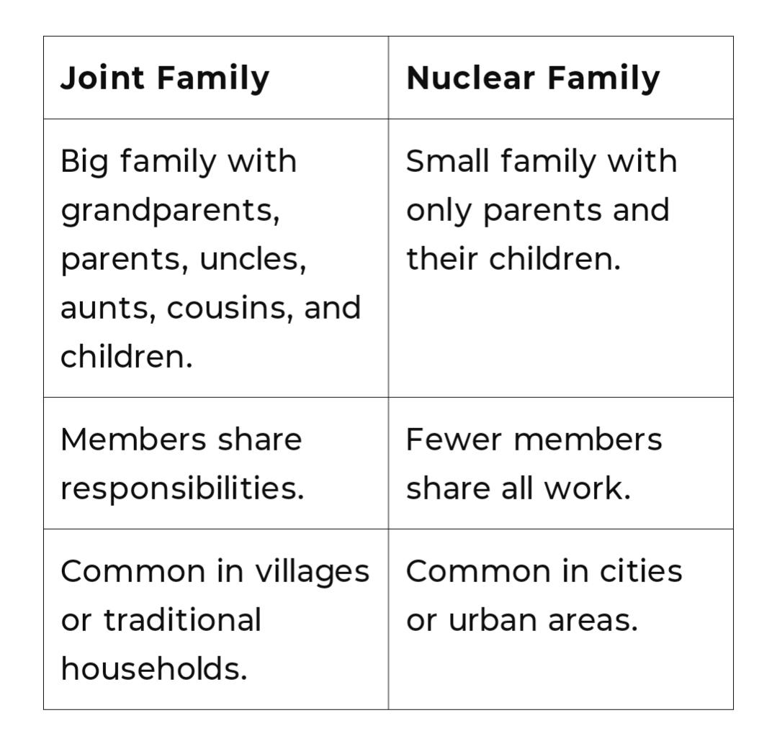
  - Children: Help in small tasks, study, and respect elders
  - Grandparents: Share wisdom, tell stories, and provide love.
  - Working together helps the family stay strong and happy.

What is a Community?
- A community is a group of people who live together in the same area and share common interests, culture, or goals.
- Examples: School community, neighborhood, village or town.
- People in a community help each other and work for the common good.
Joint Family and Nuclear Family

